Indian Institute of Technology Bombay
DEPARTMENT OF METALLURGICAL ENGINEERING & MATERIALS SCIENCE
MM 204 Transport Phenomena : 2019-20 : Spring
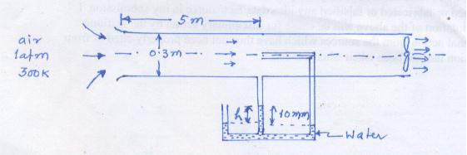
Tutorial 3 Jan 29, 2020
- A fan draws air at 1 atm. pressure and 300K from a room through a 0.3m diam tube and discharges it at 1 atm. pressure outside. Measurements made give the value as shown in the figure. Friction losses are negligible.
  - Calculate the average velocity inside the tube.
  - The value of h
  - The mass flow rate and the rating of the fan if the fan efficiency is 0.5
(assume flow to be uniform across the cross-section)
- (a) For laminar flow through a straight pipe in the fully developed flow region, perform a force (or momentum flux) balance and show that (continuing from the class):

τ_{rz} = $=(\frac{P_{L}- P_{o} }{2L}) r$ +$\frac{C_{1}}{r}$;

where P = p – ρ.g_{z}.z ( ΔP is what manometer measures)
Apply Newtons’s law of viscosity: τ_{rz} = $- μ \frac{∂V_{z}}{∂r}$, and show that
$V_{z}\left(r\right)=-\left(\frac{P_{L}- P_{o} }{4μL}\right)r^{2} + \frac{C_{1}\ln{r}}{μ}+ C_{2}$

Evaluate the boundary conditions :
i) at r =R_{o}, V_{z} =0 (no slip); ii) at r = 0; τ_{rz} = 0 ($\frac{{∂V}_{z}}{∂r}=0;symmetric)$, and show that

$V_{z}=(\frac{P_{L}- P_{o} }{4μL}) R_{o}^{2} \left\{1- {\left(\frac{r}{R_{0}}\right)}^{2}\right\}$

- From the above result, derive expressions for the following:
  - Average velocity $\overline{V_{z}}$ at any cross section;
  - Flow rate Q (Hagen-Poseuille equation)
  - Force on the tube wall for a length L. Is there an overall force balance?
  - Energy loss due to friction per unit mass $\hat{W}$_{fr} due to friction over a length L.

